Course Project - Messages from an Ad

Shaun Pritchard

Rasmussen College

PSY3738

Maria Karabekou

October 29, 2020

**Course Project - Messages from an Ad**

This research was conducted on IKEA BookBook video. Ikea's launched BookBook after Apple's iPhone 6 release date in 2015 coincidentally. An Ad agency named BBH produced a pretty clever and hilarious ad for Ikea. The ad was promoting Ikea's 2015 catalog as though it where a new release of a mobile device. It was a comparative spoof to Apple's iPhone. It was a pretty blatant and less directly satirical piece on tech commercials and over-the-top tech enthusiasm in general *(Ikea, 2015)*.

**Ikea Images from the video:**

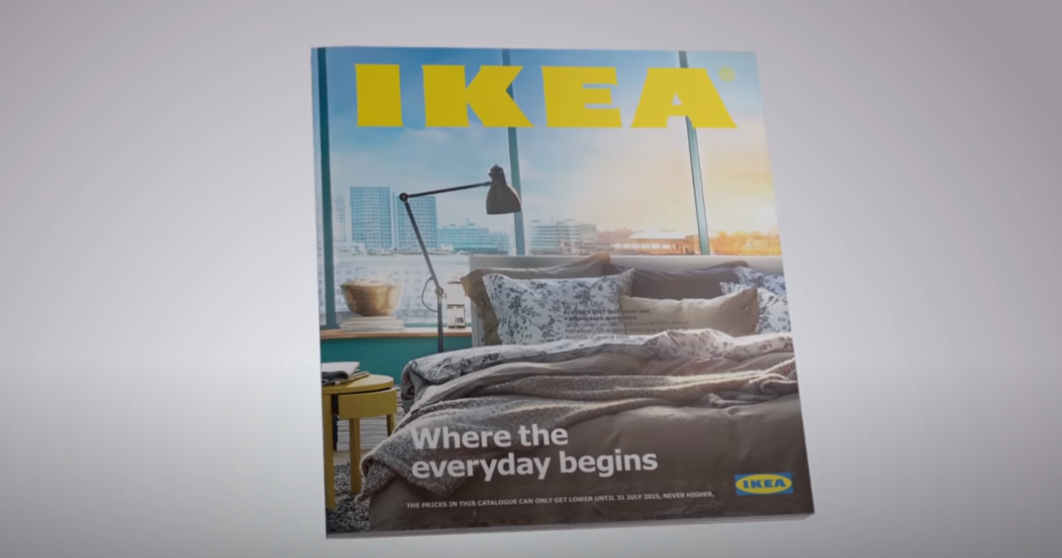

**The narrator discusses the Ikea Book as if it where a mobile device:**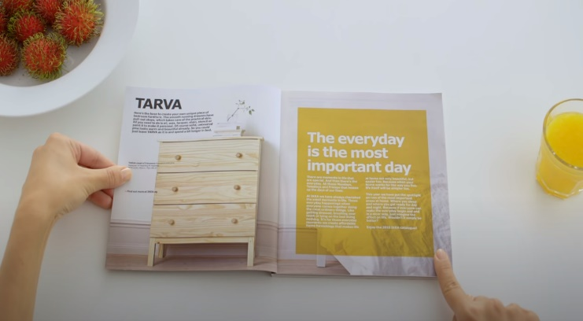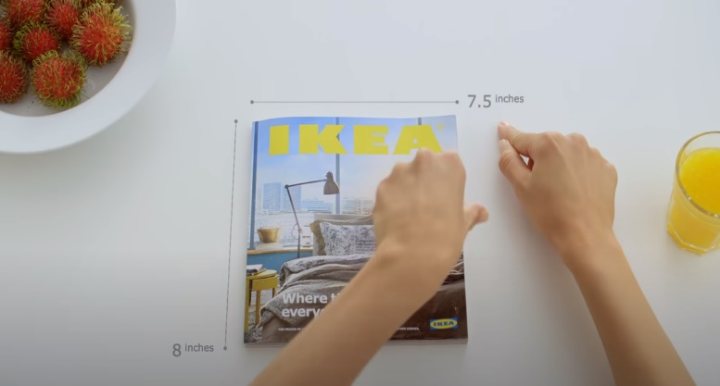

I believe the commercial intent was to connect Ikea products to familiar ads being used to sell the mobile device at the time. Also, to reach a tech-minded culture with a parody of satire and fun. Which aligns itself perfectly with the parody’s core message of innovating through simplicity.

The video walks the viewer through the operation of using a book as if BookBook was a new mobile device. The narrator personal in the video says “a device so simple and intuitive, using it seems almost familiar,” which refers to the real book, or “BookBook,”, “At only 8mm thin, and weighing in at less than 400g, the 2015 IKEA Catalogue comes pre-installed with thousands of home furnishing ideas, Join the revolution” *(Ikea, 2015).*

**The intent of the message**

Online Social networks are one of the fastest-growing industries on the planet. Social media plays into the intent of Ikeas BookBook through content marketing and user engagement. The initial intent was for Ikea to getting the audience's intention to have a wider impact on the launch of its new catalog. Ikea prints around 200 million copies of its catalog in 27 languages for 38 countries just beating Millions of them for free.

The video reinforces the values of the brand while remaining humorous and engaging. The video further emphasizes the accessibility and easy use of the catalog, which could be either delivered free or obtained in-store. The video was initially launched for the Singapore and Malaysia markets however, its popularity soon spread worldwide.

**BookBook Stats:** *(Print Power, 2017)*

* Over 6,000 people organically uploaded photos of themselves on Instagram alone interacting with their own ‘BookBook’
* 8% increase in total sales across stores in Singapore, a 13% increase in total sales in Malaysia
* Over 1 million social media interactions across YouTube, Facebook, and Twitter
* The video retained 70% of their Malaysian and Singapore viewers until the very end compared to an industry average of just 40%
* Over 19 million views on YouTube alone.
* 433k views from Singapore and 440k from Malaysia within the first few weeks of launch
* The video outranked both Apple’s and Samsung’s new product videos on Mashable’s list in September 2014
* #1 most watch video in Singapore and #3 in Malaysia in September 2014

**Ideas and opinions:**

I think creating this book video was a very clever and strategic move on Ikea's part. Essentially to engage people and retain people's attention. It does not hurt to model something already familiar and being used by other people as far as marketing strategies go. Especially when it is a parody twist on something familiar. This allows people to engage on a deeper level.

We can see from the statistics; they were able to increase their total sales and got a massive engagement that benefited their sole psychological impact. In retrospect, they timed the launch perfectly to appeal to the interactions and trends of the time. More so than now every new release of the iPhone is always been bigger and better, and people could not wait to get their hands on it from a marketing aspect. This was a trend with iPhones that Ikea took and incorporated its spin to a regular Ikea catalog book. based on a marketing tactic of something popular and proven at the time *(Infonewt.com, 2020)*.

**What can we learn:**

What can we learn about how businesses use Twitter, Facebook, Linked In, etc. to communicate, network, broaden their customer base, and promote their products/services. Having a social media presence with an appropriate strategy and plan can be very successful for businesses. Strategic marketing approaches focus on creating and distributing valuable, relevant, and consistent content to attract and retain a clearly defined audience. In essence, social media allows us to retain user attention and communicate through online networks to facilitate engagement through influence *(Socialmediaexaminer.com, 2010).*

# **Bibliography**

Ikea (2015). Experience the power of a bookbook. (Singapore) (Malaysia).

Infonewt.com. (2020, March 03). *VISUALIZING APPLE PRODUCT RELEASE PATTERNS*. From https://infonewt.com: https://infonewt.com/apple-release-patterns

Print Power. (2017, Aug 29). *How IKEA unleashed the power of the "Bookbook"*. From https://www.printpower.eu: https://www.printpower.eu/case-studies/ikea-bookbook/

Socialmediaexaminer.com. (2010, June 15). *4 Ways to Measure Social Media and Its Impact on Your Brand*. From https://www.socialmediaexaminer.com/: https://www.socialmediaexaminer.com/4-ways-measure-social-media-and-its-impact-on-your-brand/